

Value a stock:

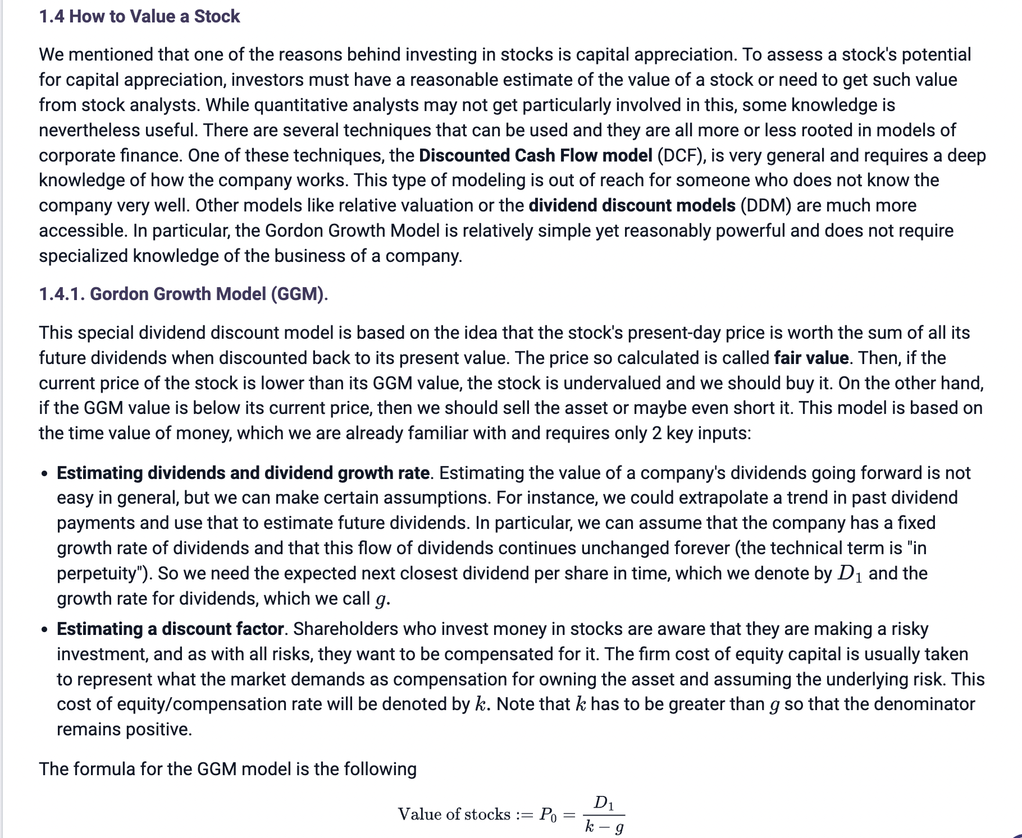

D1: the expected next closest dividend per share in time

g: the growth rate for dividends

k: cost of equity/compensation rate

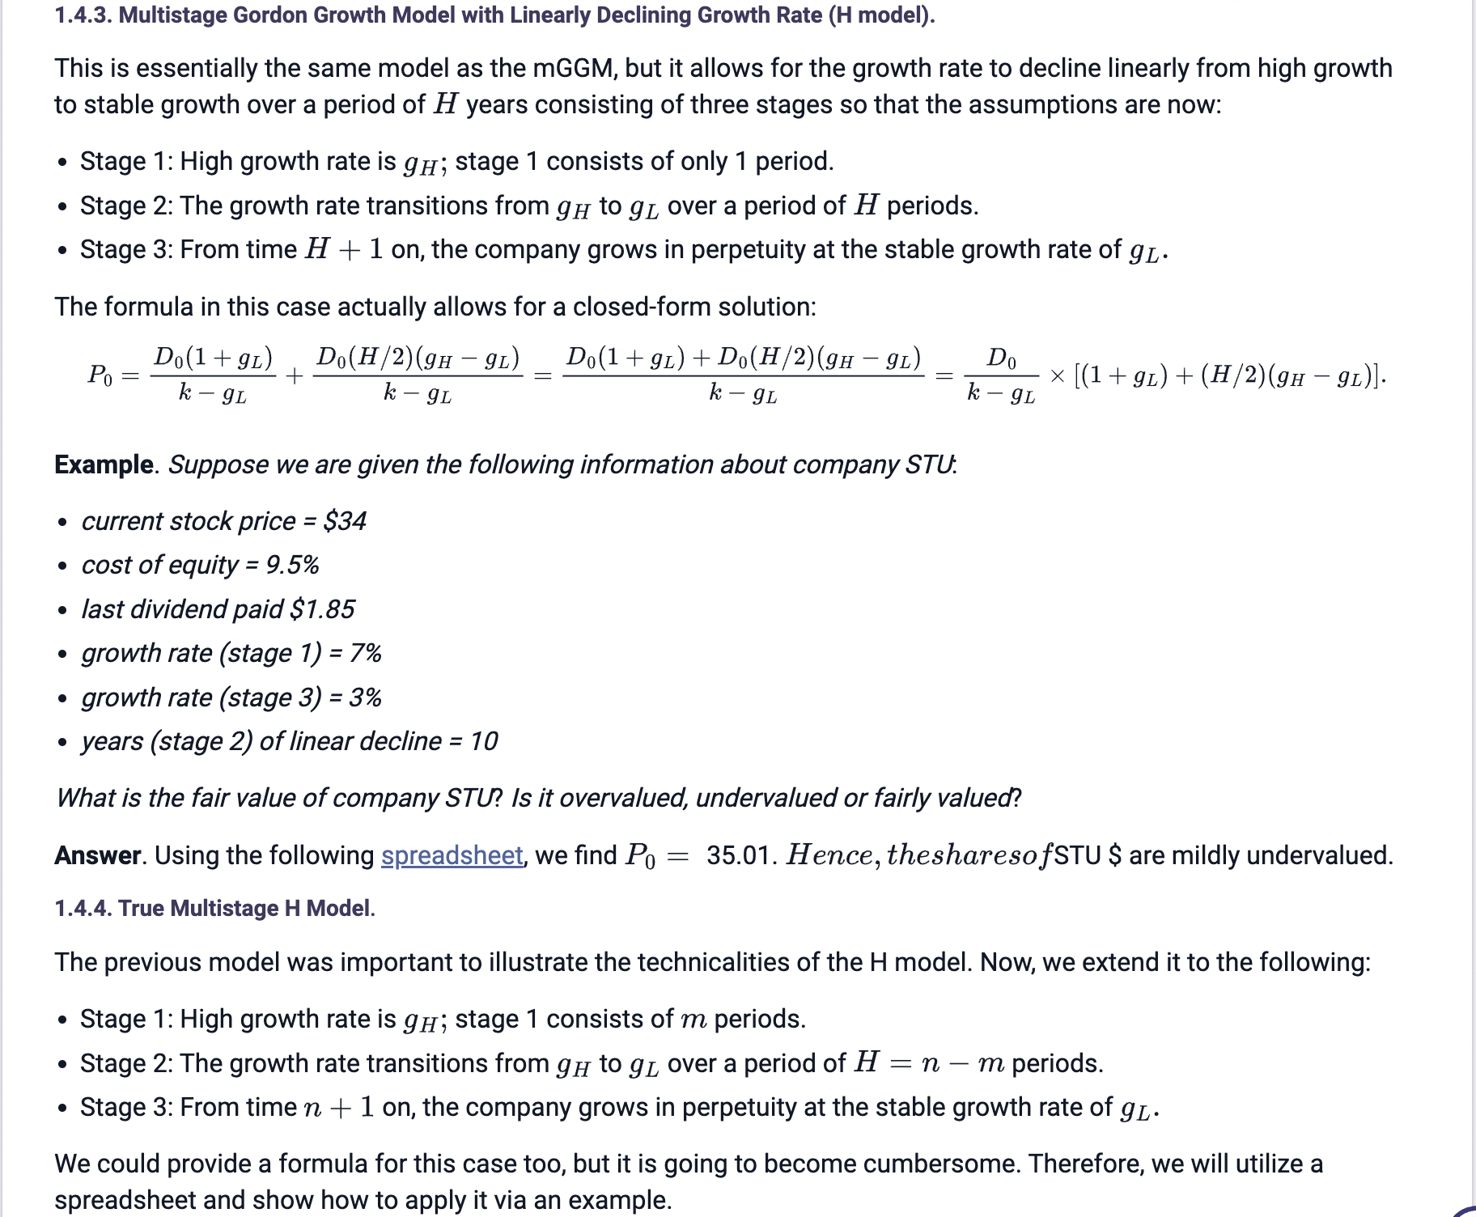

Measure the performance of stocks:

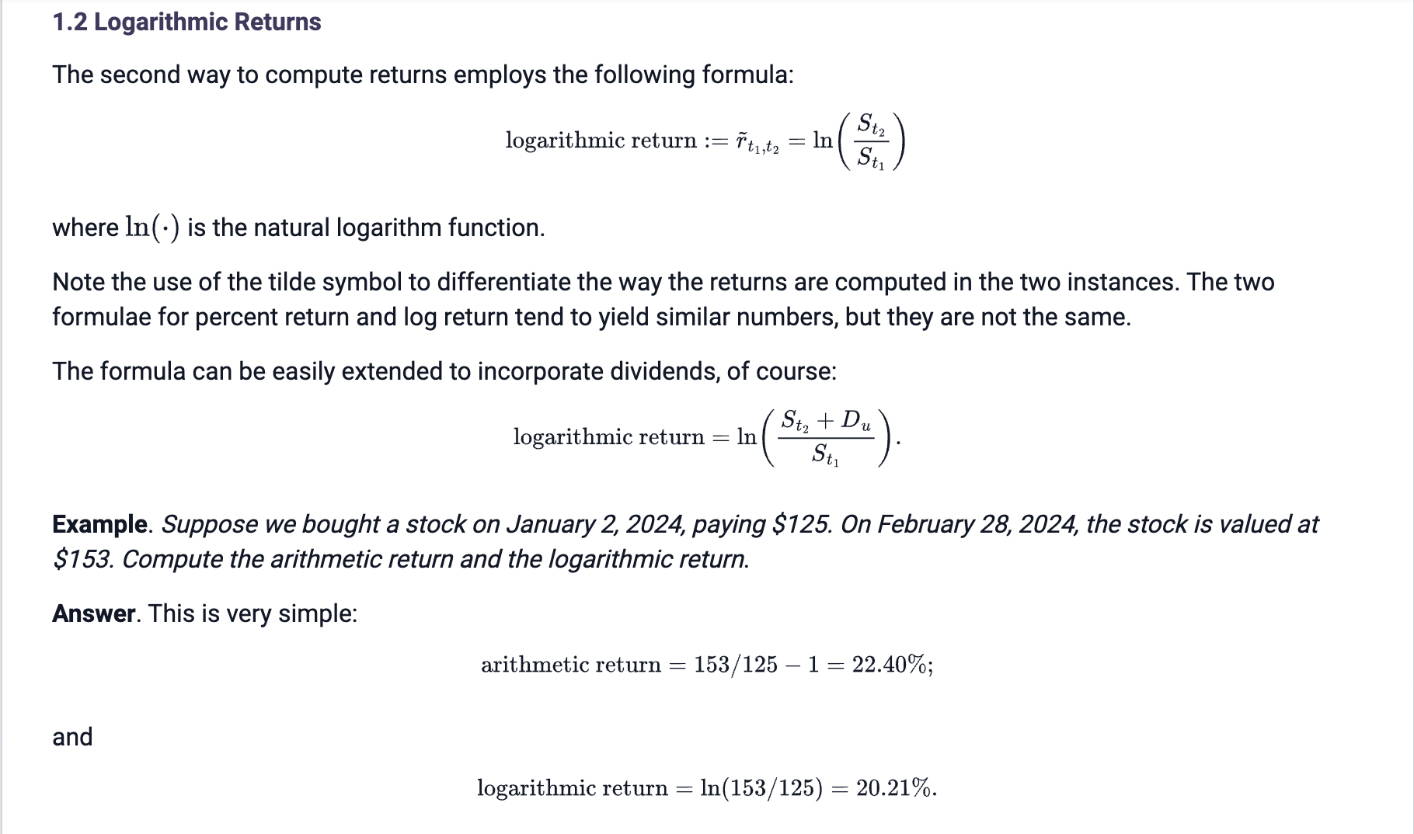

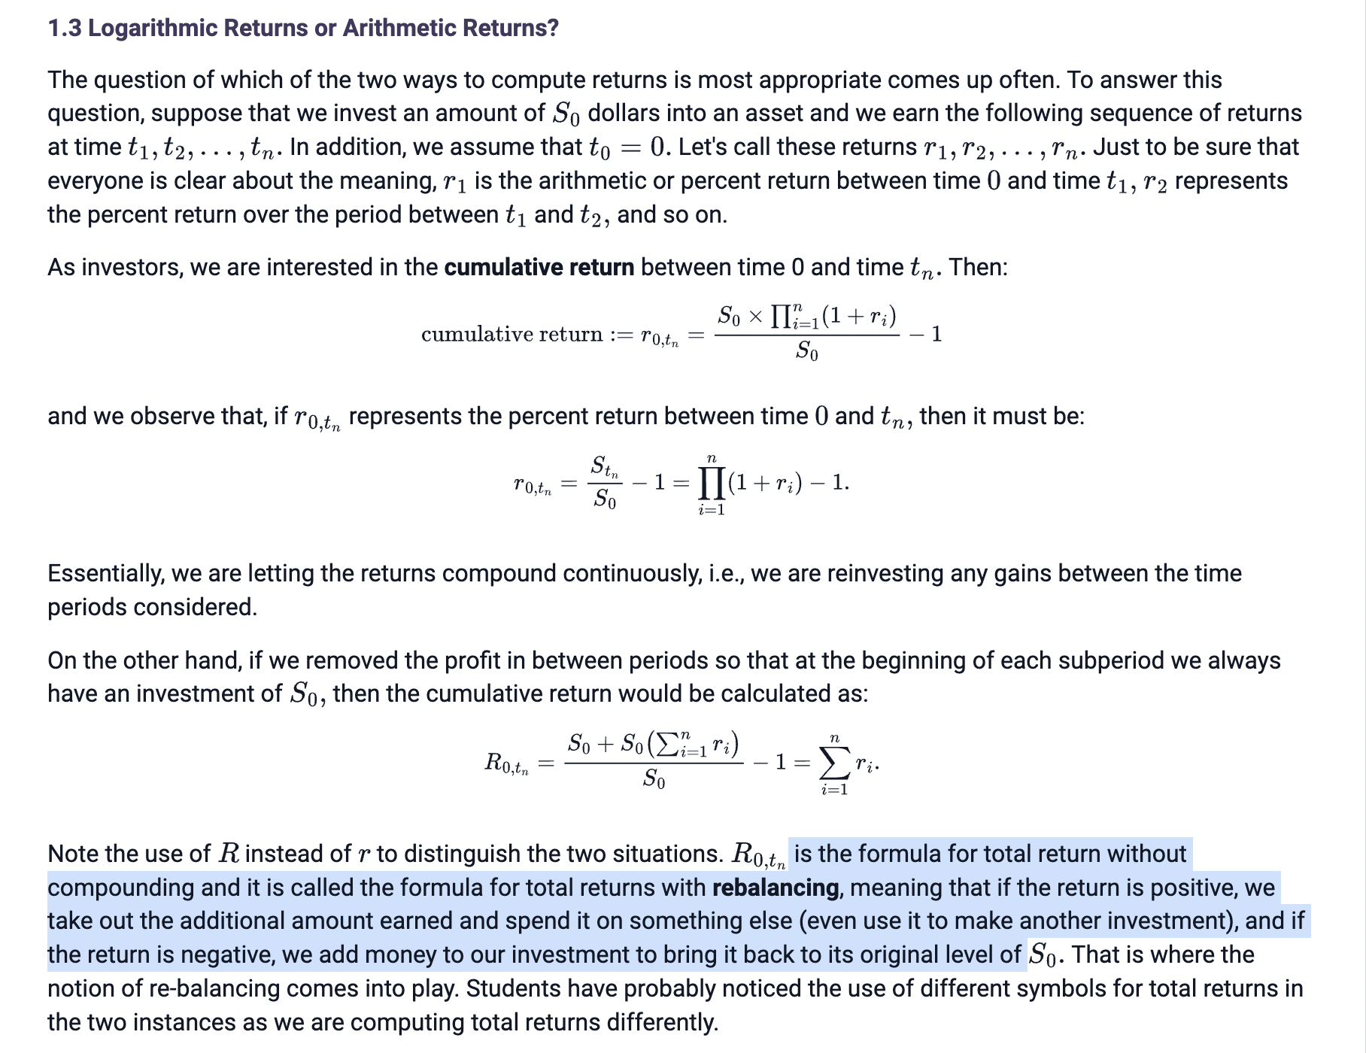

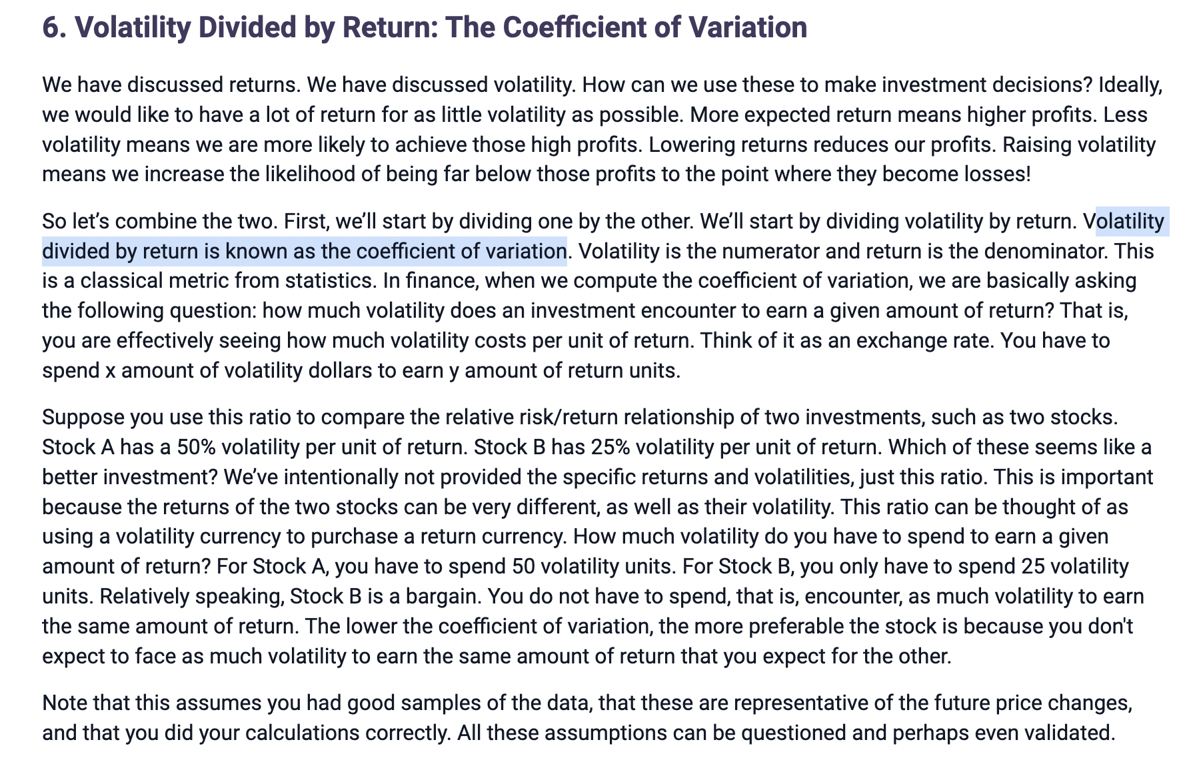

The lower the coefficient of variation, the more preferable the stock is because you don't expect to face as much volatility to earn the same amount of return that you expect for the other.

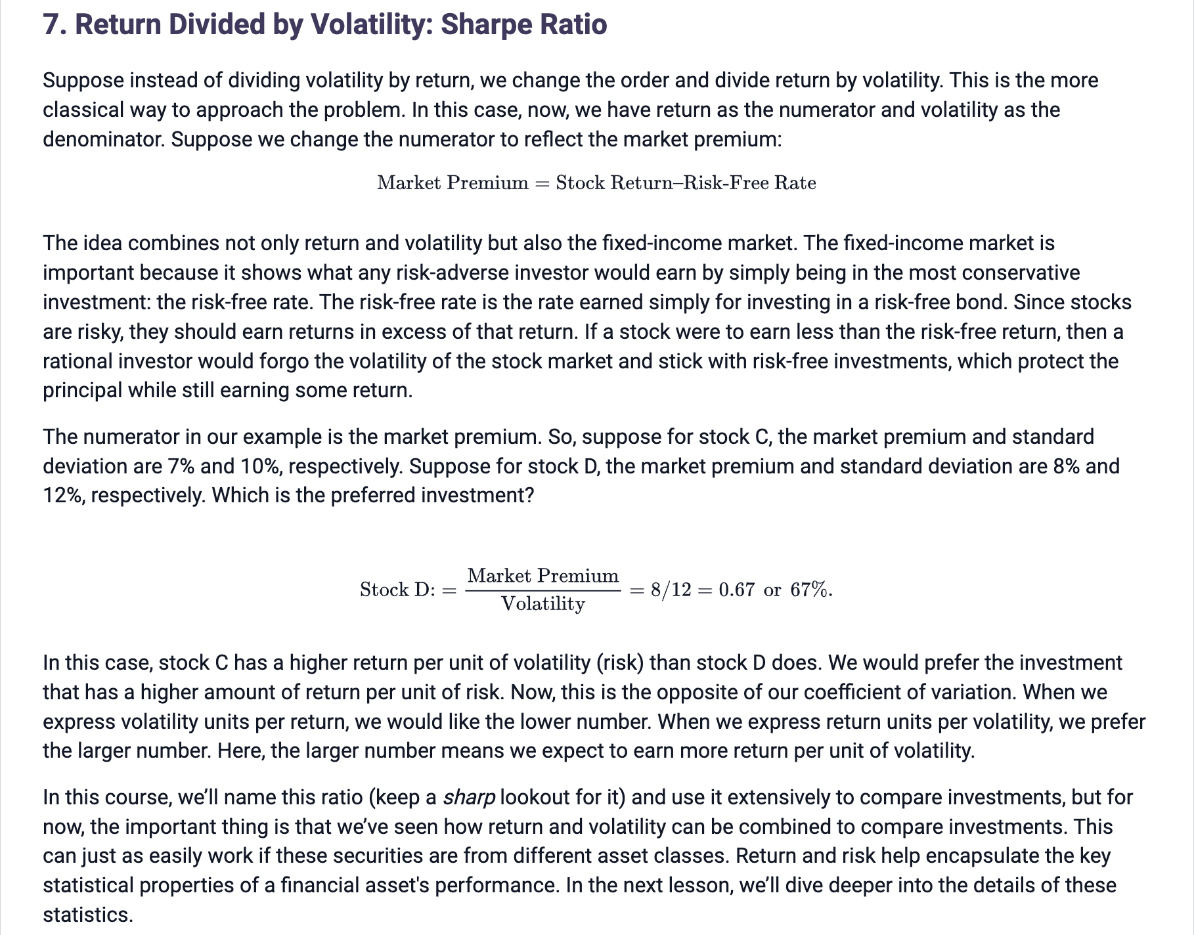

When we express return units per volatility, we prefer the larger number. Here, the larger number means we expect to earn more return per unit of volatility.

Model the performance of stocks:

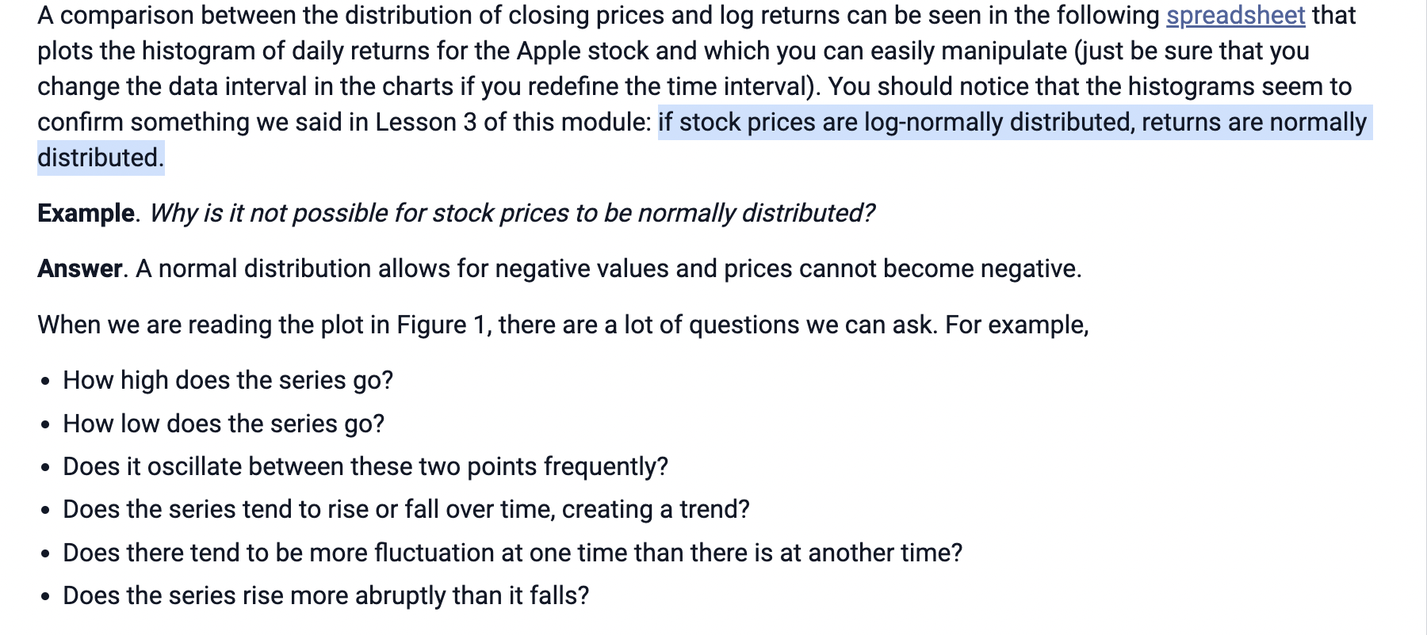

if stock prices are log-normally distributed, returns are normally distributed.

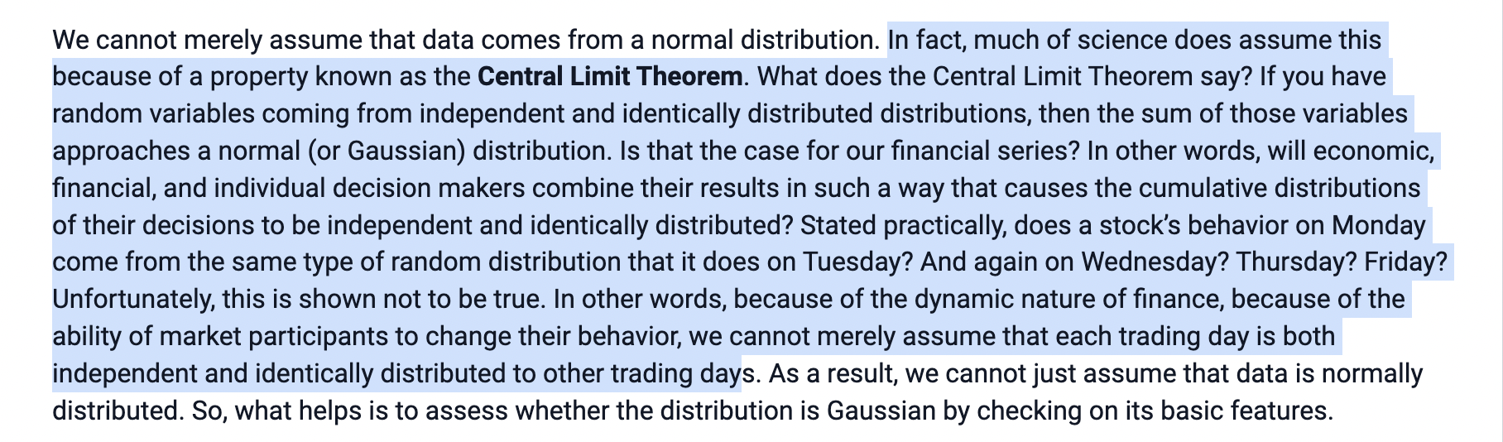

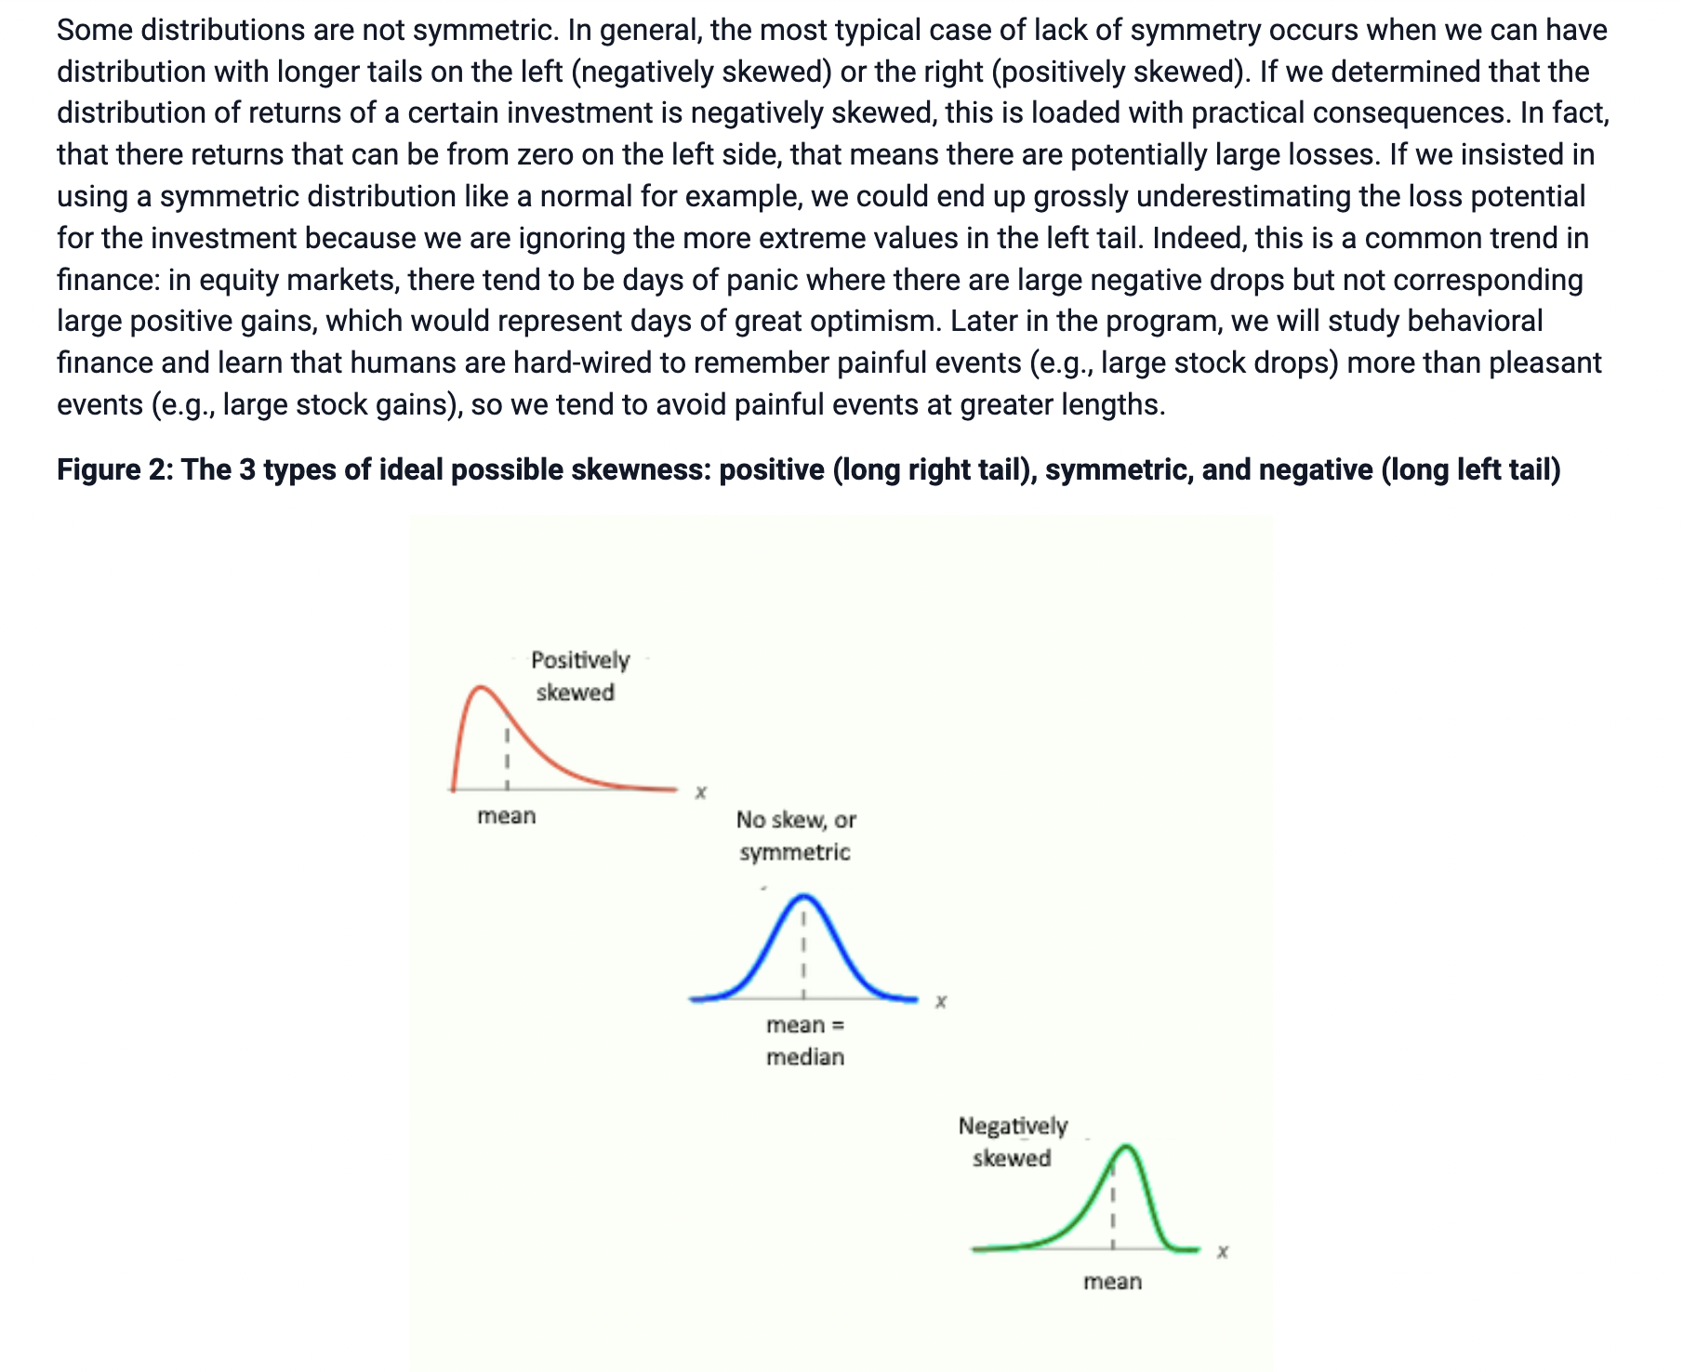

Skewness:

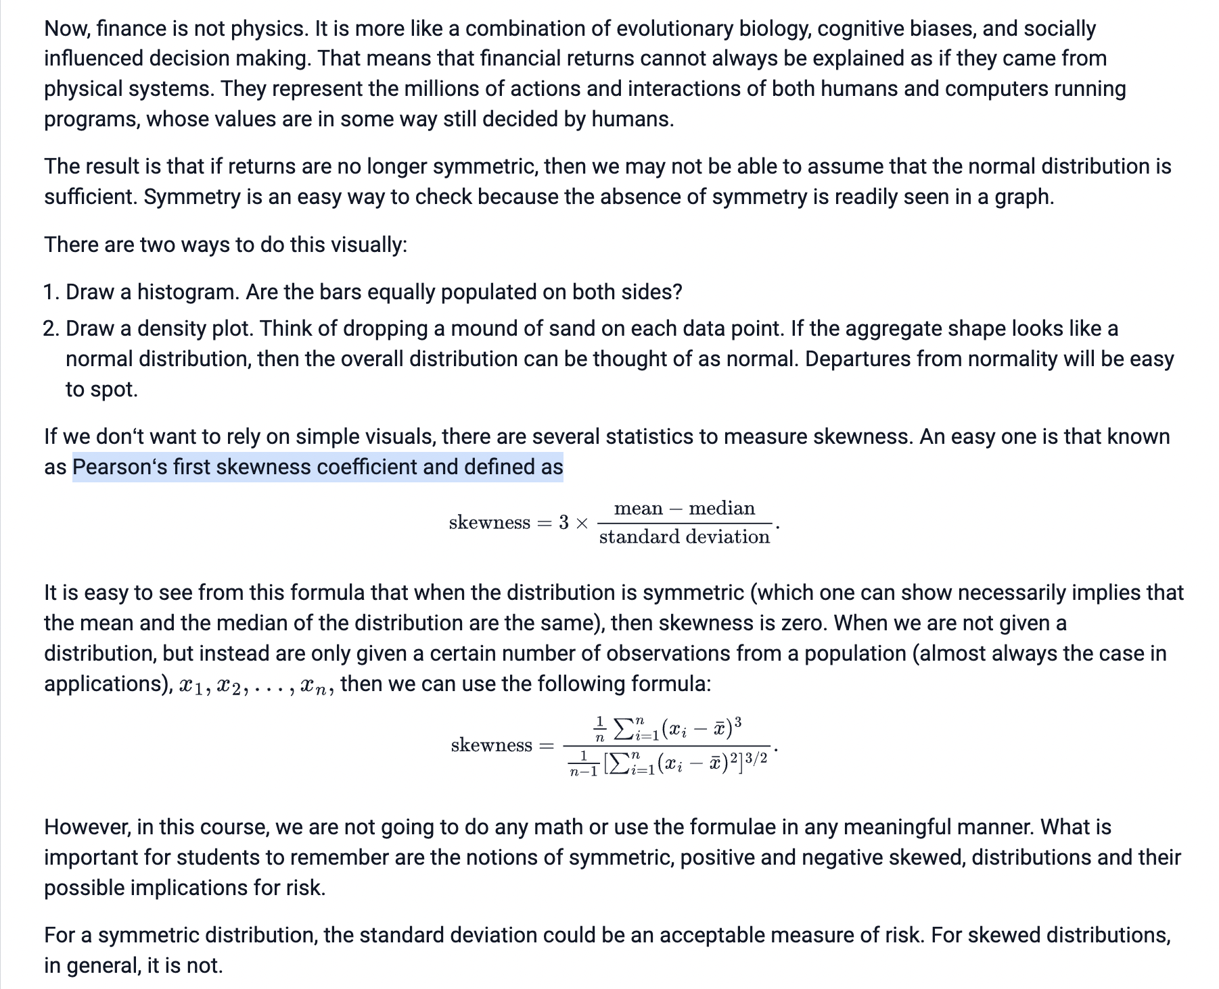

excess kurtosis:

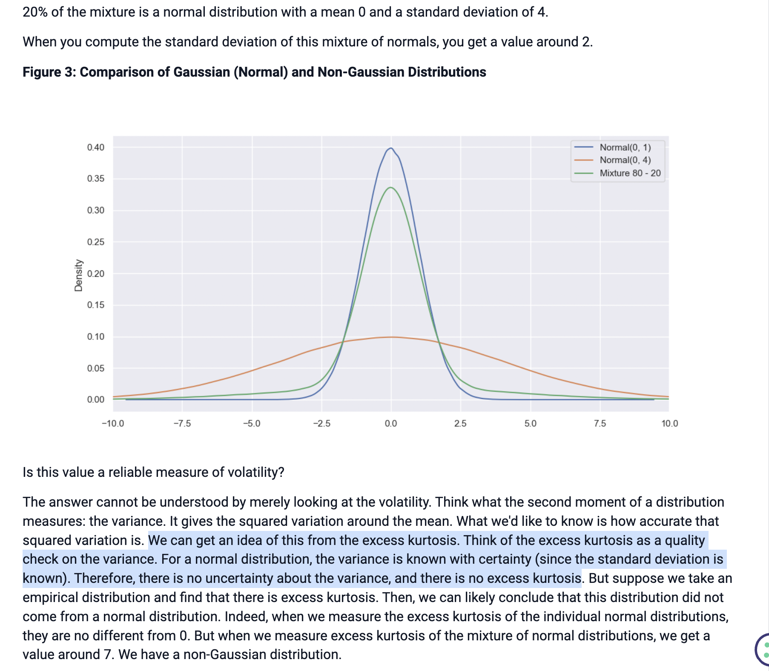

But when we measure excess kurtosis of the mixture of normal distributions, we get a value around 7. We have a non-Gaussian distribution.

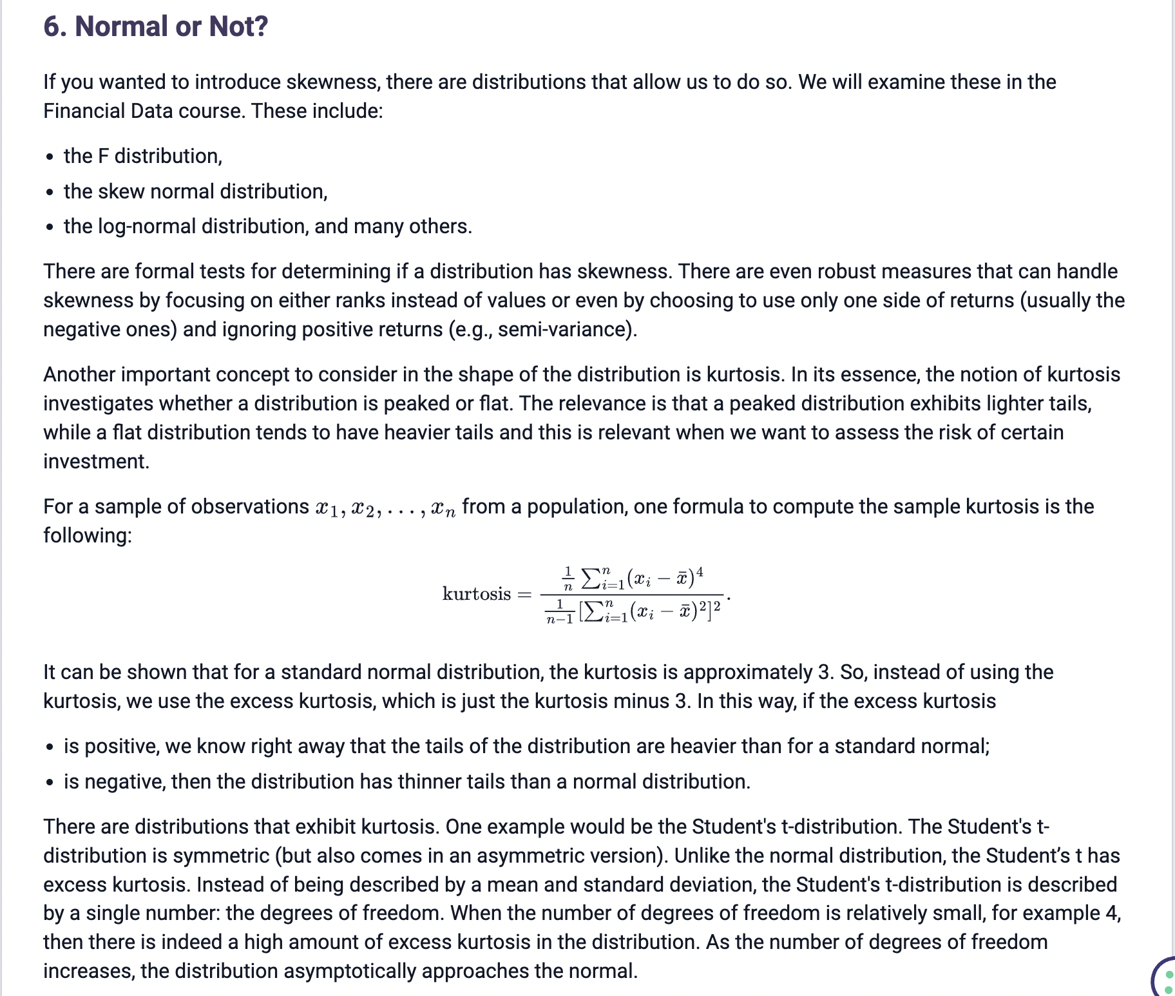

In its essence, the notion of kurtosis investigates whether a distribution is peaked or flat. The relevance is that a peaked distribution exhibits lighter tails, while a flat distribution tends to have heavier tails and this is relevant when we want to assess the risk of certain investment.

It can be shown that for a standard normal distribution, the kurtosis is approximately 3. So, instead of using the kurtosis, we use the excess kurtosis, which is just the kurtosis minus 3. In this way, if the excess kurtosis.

When the number of degrees of freedom is relatively small, for example 4, then there is indeed a high amount of excess kurtosis in the distribution. As the number of degrees of freedom increases, the distribution asymptotically approaches the normal